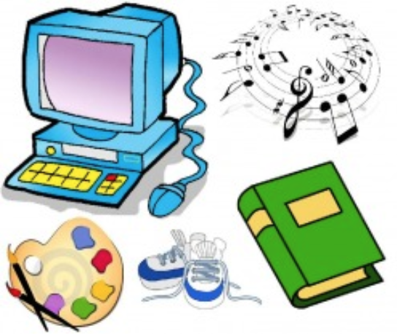

Monday | Tuesday | Wednesday | Thursday | Friday
PE | ART | Music | Computer | MakerSpace /STEM
Remember to wear proper shoes for PE.

